**Copy Artifact Plugin:**

* This plugin is to copy any artifacts from the any or upstream job

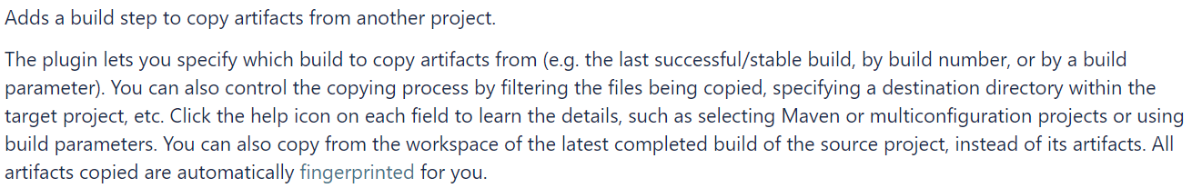

* We can restrict to copy the artifacts from upstream job as below

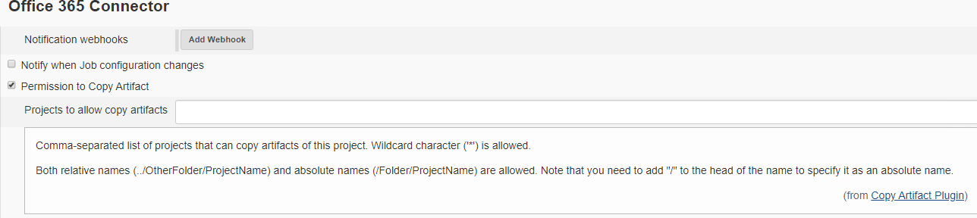

* And then we can configure as below in downstream job to copy the artifact

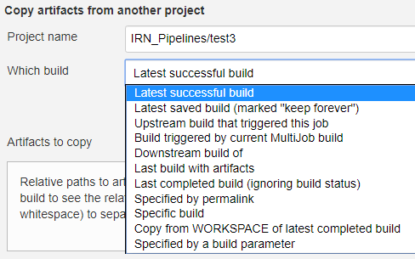

* We need to add this in build stage by selecting the above options

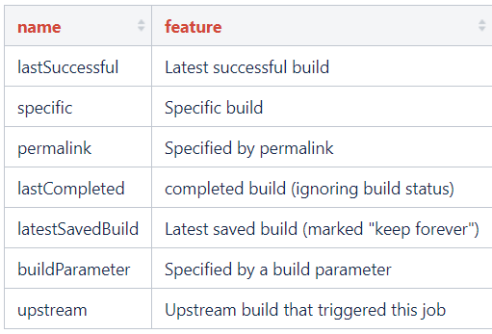

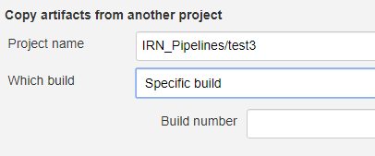

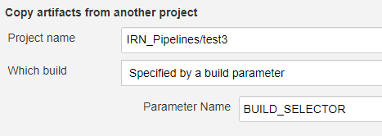

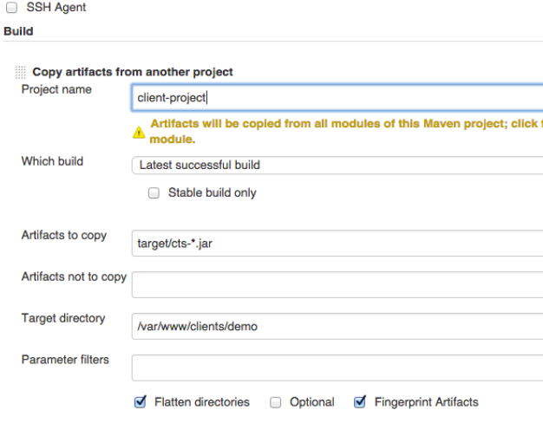

* We can also use these below options

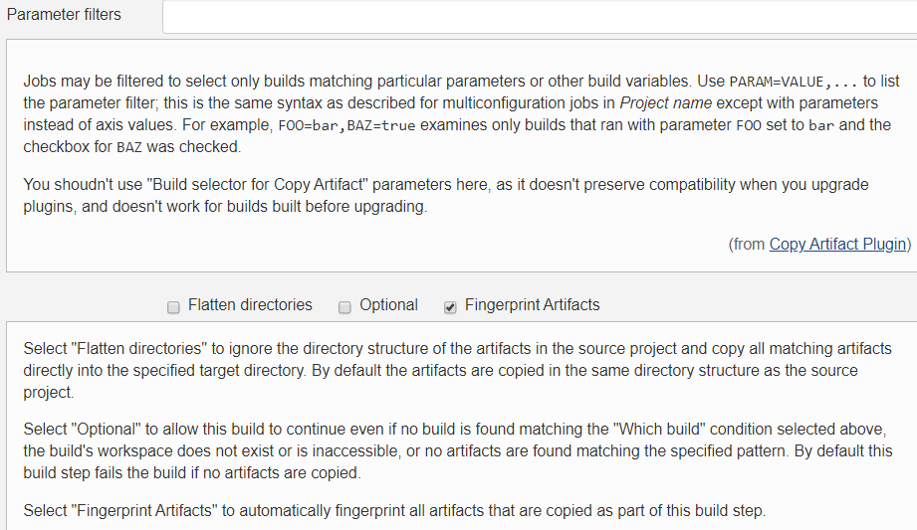

* We have to use this “build selector to copy artefact” option to copy the artifacts based on a parameter value as below

